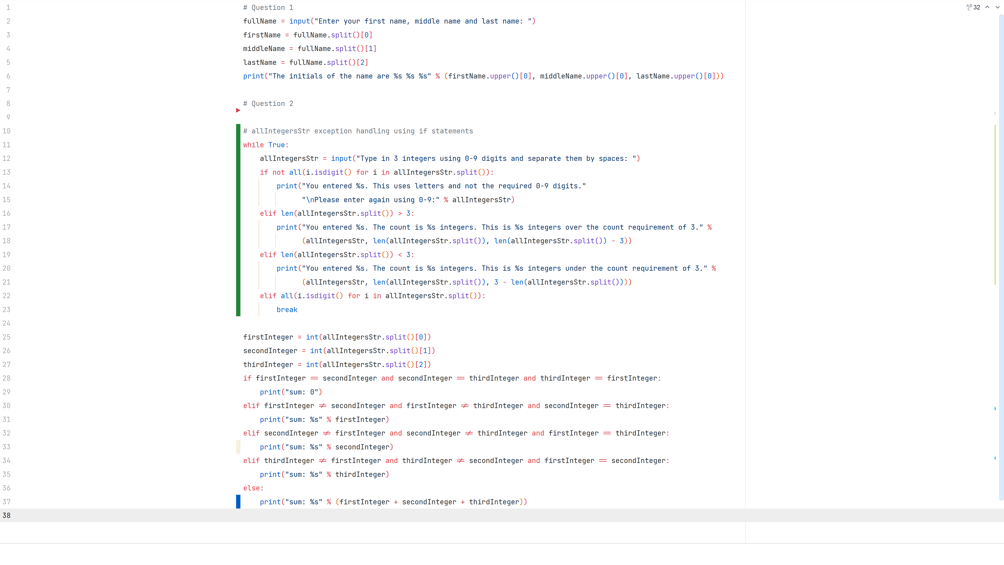

Code

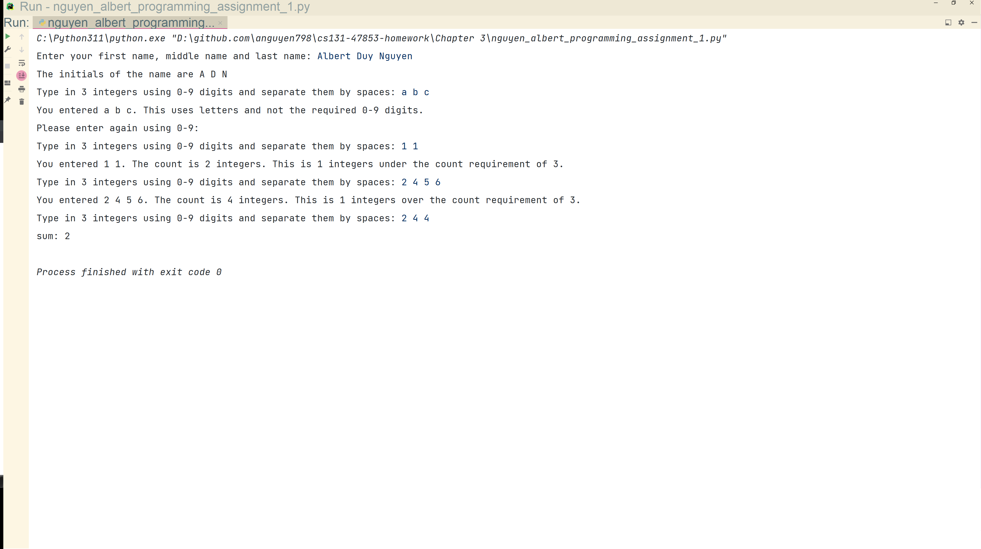

Output

Code - Chapter 3 Programming Assignment 1
Output - Chapter 3 Programming Assignment 1

